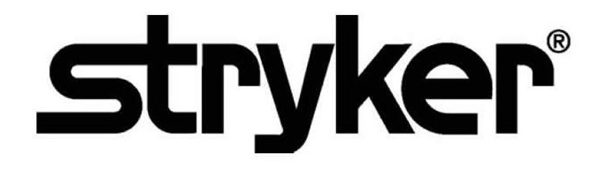

**SmartMedic™**

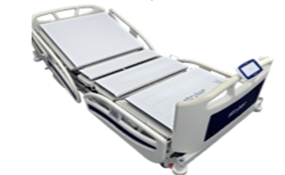**Security Operations Manual**



~~REF: 6007-670-000~~

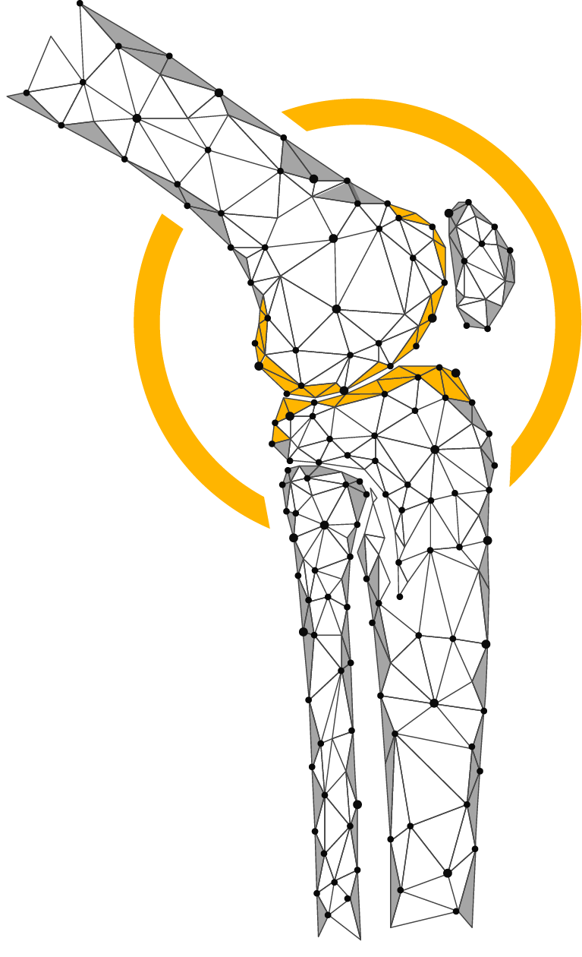

**Table of Contents**

01 Purpose 3

02 Definitions 3

03 Product Description 4

3.1 Device and Manufacturer Identification 5

3.2 Device Intended Use 5

3.3 Vulnerability Intake and Monitoring 6

3.4 System Characterization and System Assets 6

3.5 System Security Context and Intended Environment 6

3.6 Smart Medic Solution’s Component 7

04 User Account Management 7

05 Access control policy and management 7

06 Security Awareness Training 8

07 Incident Management, Response, Training, Testing, Handling, Monitoring & Reporting 8

08 Contingency Plan: Testing, Maintenance and Training 9

09 Trustworthiness- CIA Triad & Their Responsibilities 10

10 System Maintenance 11

11 Configuration settings 11

12 System and information integrity 11

13 Malicious code protection 12

14 Information system monitoring 12

15 Information handling and retention 12

16 Transmission confidentiality and integrity 12

17 Security Alerts, Advisories, and Directives 13

18 Flaw remediation & Vulnerability Management 13

19 Cyber Security Product Upgrades 14

20 Security Program Integration 14

21 Secure Decommissioning 14

22 Automatic Log-Off 14

23 Malware Detection/Protection 14

24 Roadmap for Third Party Components in Device Life Cycle 15

25 Health Data Storage Confidentiality 15

26 System and Application Hardening 15

27 Physical Locks 15

# 01 Purpose

This Security Operations Manual (SOM) provides information that Stryker’s customers need to know in order to integrate a specific Stryker device or health IT solution into a customer’s IT network environment in a secured manner.

It also supports customer’s ability to perform risk management, to identify configurable security controls, and to better protect their systems.

# 02 Definitions

**API – Application Programming Interface**

An interface for computing that defines interactions between multiple software intermediaries.

**Customer**

The individual or organization responsible for procurement and operation of the device. See Owner and Operator.

**Device**

The item being integrated or used for a healthcare purpose. A Medical Device or other health IT product may be referred to as a Device or a Product in this document.

**HDO – Healthcare Delivery Organization**

Also “Health Delivery Organization,” an organization or group of organizations that are involved with the delivery of healthcare services. A hospital is an HDO. If an HDO purchases and operates a Stryker device, the HDO is also the Customer, Owner, and Operator per the definitions of those terms.

**ISO – International Organization for Standardization**

An international standard-setting body that promotes proprietary, industrial, and commercial standards, and publishes standards relevant for information technology, privacy, and security (for example, ISO/IEC 27034). Refer www.iso.org

**Manufacturer**

The entity (Stryker) that builds the device and sells it to the customer.

MDR – European Union (EU) Medical Device Regulation of 2017

The European Union regulation concerning medical devices.

Refer https://ec.europa.eu/health/md_sector/overview_en

**Medical Device**

See the following sources if a precise definition is required: FDA, MDR (EU) 2017/745, ISO 14971:2007.

**Operator**

The person(s) using the device for its intended purpose. This term may also sometimes refer to the person or organization responsible for procuring the device (owner, customer).

**Owner**

See Operator and Customer.

**PHI – Protected Health Information**

Individually identifiable health information (IIHI) that is transmitted by electronic media; maintained in electronic media; or transmitted, or maintained, in any other form or medium (source: extracted from 45 CFR Section 160). Note: This is a subset of PII.

**PII – Personally Identifiable Information**

Any information about an individual maintained by an agency, including the following:

Any information that can be used to distinguish or trace an individual’s identity.

Any other information that is linked or linkable to an individual, such as medical, educational, financial, and employment information (source: from NIST SP 800-122).

**Product**

See Device.

**SOM - Security Operations Manual**

A product-specific guide to the secure integration of a product into a customer IT network (this document).

**Third-party software**

Third party software is software not developed by Stryker, and for which Stryker otherwise does not have complete ownership. See COTS and OSS.

**User**

See Operator.

# 03 Product Description

This Security Operations Manual (SOM) provides information that Stryker’s customers need to know in order to integrate a Stryker’s SmartMedic solution into a customer’s IT network environment in a secured manner.

It also supports customer’s ability to perform risk management, to identify configurable security controls, and to better protect their systems.

|  |  |
| --- | --- |
| **Manufacturer Name** |  |
| **Stryker Division** | Stryker Global Technology Center |
| **Address** | **Stryker Global Technology Center Private Limited**  10th Floor, Vatika Business Park,  Block Two, Sector-49 ,Sohna Road,  Gurgaon 122002, Haryana, India |
| **Device Description** | SmartMedic Device solution is used to monitor the health vital data i.e weight, temperature, position. The SmartMedic Device is intended to provide an alert for the unwanted change the health vital, that uses the device’s data to visualize the current health condition of patient in the real time to enable effective decision making for the health personal before they even go into the operating room on the daily health inspection. |
| **Device Model, Version** | **~~6007-670-000 V1.0 (Further digits for minor fixes controlled internally)~~** |
| **Manufacturer Contact**  **Information** | **Manufacturer:**  **Stryker Global Technology Center Private Limited**  10th Floor, Vatika Business Park, Block Two, Sector-49, Sohna Road, Gurgaon 122002, Haryana, India  **Distributed By**:  **Stryker Japan K.K**.  2-6-1, Koraku, Bunkyo-ku,Tokyo, 112-004, Japan t/f: 03-6894-0000  Additional information and contact links are available on Stryker’s Product Security webpage, https://www.stryker.com/us/en/about/governance/cyber-security.html. |

*Table 1.1 Product Description*

## 3.1 Device and Manufacturer Identification

**Device**

SmartMedic Device

**Manufacturer**

**Stryker Global Technology Center Private Limited**

10th Floor, Vatika Business Park

Block Two, Sector-49, Sohna Road,

Gurgaon 122002, Haryana, India

## 3.2 Device Intended Use

SmartMedic Solution used to retrieve the health vital data i.e. weight, position etc. The SmartMedic Device intended to provide an alert for the unexpected change the health vital, which uses the device’s data to visualize the current health condition of patient in the real time to enable effective decision making for the health personal before they even go into the operating room on the daily health inspection.

Functionality Includes:

* Retrieve the health vital data i.e. weight, position etc.
* SmartMedic solution provide an alert for the unexpected changes in the health vital.
* Device’s data to visualize the current health condition of patient in the real time.
* Visualize the current health condition of patient in the real time.
* Enable effective decision making for the health personal

## 3.3 Vulnerability Intake and Monitoring

When Stryker obtains vulnerability information through surveillance or other sources, an assessment of the vulnerability’s exploitability and impact conducted. Based upon the assessment Stryker determines if further actions are required like, providing security updates and/or providing communication to the customer in a timely manner. Vulnerability information may also be requested from Stryker at any time.

Any potential security vulnerabilities customer may become aware of due to SmartMedic Device must be communicated to Stryker customer care and the same will be handled through the post market complaints management process to do the assessment and required actions including any updates needed for the customers.

## 3.4 System Characterization and System Assets

SmartMedic Solution used to monitor the health vital data i.e weight, temperature, position. The SmartMedic Device intended to provide an alert for the unexpected change the health vital, which uses the device’s data to visualize the current health condition of patient in the real time to enable effective decision making for the health personal before they even go into the operating room on the daily health inspection. This device only allowed for sending data and information to SmartMedic solution’s tablet that further sends data to the Stryker cloud storage for further analysis. This device will not allow user to transfer the patient data to any other external or connected system to process further. The patient data encrypted and stored locally and cloud under the particular logged user hospital entity.

## 3.5 System Security Context and Intended Environment

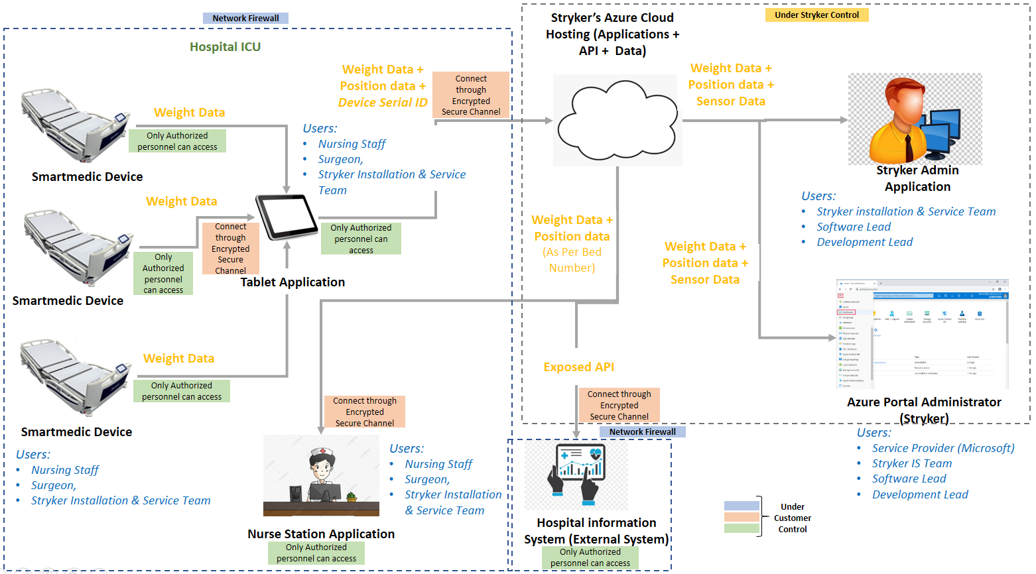

*Figure 1: System Security*

While there is specific requirement for SmartMedic solution to be a usual good network security and communication tools environment, however Stryker recommends the user to follow the best practice security standards in order to run the SmartMedic solution in a safe and secure environment as follows:

Devices operating in the intended use environment should consider that their IT infrastructure must follow different risk management approaches associated with their networks. Some recommendations are:

* Good physical security to prevent unauthorized physical access to SmartMedic Device application.
* Access control measures to ensure only authenticated and authorized personnel are allowed access to network elements, stored information, services and applications.
* Communication between SmartMedic solution’s tablet and SmartMedic application should be in the encrypted secure channel.
* General patch management practices that ensure timely security patch updates.
* Use the good network security and communication tools.
* Security awareness training.

## 3.6 Smart Medic Solution’s Component

**SmartMedic Solution Component: Device**

SmartMedic device consist of the sensors that used to retrieve the health vital data such as weight, position etc. This device only allowed for routing data and information to SmartMedic solution’s tablet.

**SmartMedic: Tablet**

SmartMedic solution’s tablet that further route data to the Stryker cloud storage for further analysis. The tablet collects the data from all the smart medic devices which of them configured to route the data towards the SmartMedic cloud application.

**SmartMedic: Nurse Station Application**

SmartMedic: Nurse Station Application get an alert for the unexpected change of the health vital, which uses the device’s data to visualize the current health condition of patient in the real time to enable effective decision making for the health personal before they even go into the operating room on the daily health inspection.

**SmartMedic: Communication Network**

SmartMedic: communication network used to transmit the information from the source to the destination.

# 04 User Account Management

**SmartMedic: Tablet**

***Existing Security Features:***Only Stryker’s service engineer authorized to manage user account

***Recommendation for customer (HDO):*** No user account management by HDO/hospital staff.

**SmartMedic: Nurse Station Application**

***Existing Security Features:*** HDO/hospital staff only authorized to manage the user account on the Nurse Station web application. The Stryker will provide the personal authentication credential for the same.

***Recommendation for customer (HDO):*** No user account management by customer. Stryker’s customer can access the Nurse Station web application using the credentials provided by the Stryker.

# 05 Access control policy and management

**SmartMedic Solution Component: Device, Tablet** **and Nurse Station Application**

***Existing Security Features:***Only Stryker’s service engineer authorized to access the SmartMedic solutions component. Whenever needed at the time of maintenance. Tablet is placed inside the enclosure. Access to tablet is only provided to Stryker Service Personnel Stryker’s customer only authorized to access the Nurse Station web application. The Stryker will provide the personal authentication credential for the same.

***Recommendation for customer (HDO):*** Stryker’s customer can access the Nurse Station web application using the credentials provided by the Stryker. The management of physical security aspects of the HDO's IT system, networks and other configuration items is a key responsibility of the HDO's IT network management.

# 06 Security Awareness Training

**SmartMedic Solution Component: Device**, **Tablet and Nurse Station Application**

***Recommendation for customer (HDO):*** Customer aware and train the user only Stryker’s service engineer authorized to access the SmartMedic solutions component device. Whenever needed at the time of maintenance. HDO did not allowed accessing and managing of device and tablet component.

HDO’s user can access the Nurse Station web application using the credentials provided by the Stryker. Log out the system whenever nurse station application not in use.

All network connections considered in determining appropriate security controls. The HDO IT team will provide the secure encrypted channel such as wireless connection like Wi-Fi (consider authentication protocols supported, such as WPA2 EAP-TLS) for the communication between the SmartMedic solution’s components i.e. the tablet and Stryker cloud.

# 07 Incident Management, Response, Training, Testing, Handling, Monitoring & Reporting

**SmartMedic Solution Component: Device, Tablet and Nurse Station Application**

***Existing Security Features:***Only Stryker’s service engineer authorized to perform testing and maintenance the SmartMedic solutions component device. Whenever needed at the time of incident response. When Stryker obtains vulnerability information through surveillance or other sources, an assessment of the vulnerability’s exploitability and impact conducted. Based upon the assessment Stryker determines if further actions are required like, providing security updates and/or providing communication to the customer in a timely manner. Vulnerability information may also be requested from Stryker at any time. The malware detection is crucial with malware’s prevalence because it functions as an early warning system for the computer secure regarding A and cyberattacks. It keeps hackers out of the computer and prevents the information from being compromised. Only Stryker Technical Team authorized to repair or resolve issue whenever severe malware has been detected.

Vulnerability Management

* Implementation of security scanning tools within the organization
* Onboarding the application/infrastructure to the scanning tool
* Identify and prioritization of the vulnerability as per vulnerability rating such as critical, High, Medium, low and information
* Planning the vulnerability remediation and mitigation options
* Tracking and revalidation of the vulnerability remediation and mitigation

Incident Response

* Suspected malware on the system
* Confirmed malware on the system
* Unexpected system behavior
* Recovery of data from a damaged or non-functional system
* Suspected misuse of the device (how to confirm through logs)
* Methods to determine if data was inappropriately accessed or copied from the device
* Forensic inspection of the device

Security Testing

* Client need to update the software or hardware if needed.
* Client need to test or validate the effectiveness of system security function
* Functional testing should be performed to identify the loop holes

Scanning

* Network security scanning and web application vulnerability scanning should be performed to remove the legacy Applications/Devices within infrastructure
* Manual and automated vulnerability scanning of the system should be performed as per the business approval

Risk Management

* Client need to conduct security risk management process which monitors the ongoing security posture of this device and addresses any security incidents that might arise.
* Risk assessment should be conducted within the organization to identify the gaps and proves improvements

Training and Awareness

* Devices functioning training should be provided and staff members utilizing the devices
* Client need to evaluate the security training requirements for this product and determined that standard user security and awareness training for business purpose to user.
* Workforce members utilizing medical devices should be appropriately trained.
* Medical device owners or designees should train appropriate workforce members on the use of the medical device to include any issues/concerns related to its use.

***Recommendation for customer (HDO):*** Customer didn’t allowed to access this component*.* Please reach out to Stryker Customer Care for incident response. Whenever severe malware has been detected and got resolved by the service engineer. Customer has to blocks the few IOCs and IOAs at their network devices. Highly Recommendation for customer (HDO) usage of the network firewall. SmartMedic solution should be behind stateful firewall. Firewall helps in preventing network access to devices. If properly used and configured it can lead to protected and reliable accessibility. It can help in prevention of unauthorized access and network connections against external threats, IP spoofing & routing attacks and malicious packets.

# 08 Contingency Plan: Testing, Maintenance and Training

**SmartMedic Solution Component: Device, Tablet, Nurse Station Application and Wireless Network**

***Existing Security Features:***Only Stryker’s service engineer authorized to perform testing and maintenance the SmartMedic solutions component device. Whenever needed at the time of maintenance. When Stryker obtains vulnerability information through surveillance or other sources, an assessment of the vulnerability’s exploitability and impact conducted. Based upon the assessment Stryker determines if further actions are required like, providing security updates and/or providing communication to the customer in a timely manner. Vulnerability information may also be requested from Stryker at any time.

***Recommendation for customer (HDO):*** Contingency planning and management (e.g. restoring a system or a network segment or certain applications) is a key responsibility of the HDO's IT network management

The organization’s contingency plan

* Develops a contingency plan for the information system that:
  + Identifies essential missions and business functions and associated contingency requirements
  + Provides recovery objectives, restoration priorities, and metrics
  + Addresses contingency roles, responsibilities, assigned individuals with contact information
  + Addresses maintaining essential missions and business functions despite an information system disruption, compromise, or failure
  + Addresses eventual, full information system restoration without deterioration of the security safeguards originally planned and implemented
  + Is reviewed and approved by defined personnel or roles
* Distributes copies of the contingency plan to defined key contingency personnel (identified by name and/or by role) and organizational elements
* Coordinates contingency planning activities with incident handling activities
* Reviews the contingency plan for the information system defined frequency
* Updates the contingency plan to address changes to the organization, information system, or environment of operation and problems encountered during contingency plan implementation, execution, or testing.
* Communicates contingency plan changes to defined key contingency personnel (identified by name and/or by role) and organizational elements
* Protects the contingency plan from unauthorized disclosure and modification.

The organization’s contingency testing

* Establishes an alternate processing site including necessary agreements to permit the transfer and resumption of defined information system operations for essential missions/business functions within defined time period consistent with recovery time and recovery point objectives, when the primary processing capabilities are unavailable
* Ensures that equipment and supplies required to transfer and resume operations are available at the alternate processing site or contracts are in place to support delivery to the site within the organization-defined time period for transfer/resumption
* Ensures that the alternate processing site provides information security safeguards equivalent to those of the primary site*.*

The organization provides contingency training to information system users consistent with assigned roles and responsibilities:

* Within defined time period of assuming a contingency role or responsibility.
* When required by information system changes.
* Defined frequency thereafter.

# 09 Trustworthiness- CIA Triad & Their Responsibilities

**SmartMedic Solution Component: Device, Tablet & Nurse Station Application**

***Existing Security Features:*** SmartMedic solution uses the strong secure communications protocol for communicating among the components. The ability of the SmartMedic solution ensure the confidentiality of transmitted sensitive information. Transmits sensitive data only via a point-to-point dedicated channel between SmartMedic device and Tablet, Tablet and SmartMedic cloud application & SmartMedic cloud application and Nurse Station Application.

***Recommendation for customer (HDO):*** Only Stryker’s customers has to make sure that SmartMedic Device has to be connected to the tablet and always up & runningand power, which make it 24x7 available. All network connections considered in determining appropriate security controls. The customer will provide the secure encrypted channel such as wireless connection like Wi-Fi (consider authentication protocols supported, such as WPA2 EAP-TLS) for the communication between the SmartMedic solution’s components i.e. Stryker Cloud and nurse Station which will maintain the confidentiality. Stryker customer has to make sure that the SmartMedic Tablet is always connected to the Internet and power. Stryker’s customer can access the Nurse Station web application using the credentials provided by the Stryker. Advised not share your personal credential to maintain the confidentiality.

# 10 System Maintenance

**SmartMedic Solution Component: Device and Tablet**

***Existing Security Features:***Only Stryker’s service engineer authorized to perform testing and maintenance the SmartMedic solutions component device. Whenever needed at the time of maintenance. Smart medic system maintenance is planned/designed & can be performed based on the component in the smart medic environment/platform.

***Recommendation for customer (HDO):*** Customer didn’t allowed to access SmartMedic device and Tablet component. Please reach out to Stryker Customer Care for system maintenance.

**SmartMedic: Nurse Station Application**

***Existing Security Features:*** When Stryker obtains vulnerability information through surveillance or other sources, an assessment of the vulnerability’s exploitability and impact conducted. Based upon the assessment Stryker determines if further actions are required like, providing security updates and/or providing communication to the customer in a timely manner. Vulnerability information may also be requested from Stryker at any time.

# 11 Configuration settings

***Recommendation for customer (HDO):*** HDOs responsibility - Configuration management is the discipline of ensuring the integrity of HDOs networking IT configuration items (SW, HW, tools, procedures, etc.)

# 12 System and information integrity

***Recommendation for customer (HDO):*** It is the HDO's responsibility to maintain the integrity for its IT systems. The Nurse Station application can be accessed through web interface on a system which is owned by the HDO. Tablet is already enclosed and hence tamper proof. Entry to the Tablet is only for Stryker service personal.

* Develop documents, and disseminates to defined personnel or roles

1. A system and information integrity policy that addresses purpose, scope, roles, responsibilities, management commitment, coordination among organizational entities, and compliance

2. Procedures to facilitate the implementation of the system and information integrity policy and associated system and information integrity controls

* Reviews and updates the current system and information integrity policy & defined frequency

# 13 Malicious code protection

***Recommendation for customer (HDO):*** It is the HDO's responsibility to maintain the integrity for its IT systems. The Nurse Station application can be accessed through web interface on a system which is owned by the HDO. Tablet is already enclosed and hence tamper proof. Entry to the Tablet is only for Stryker service personal.

Employs malicious code protection mechanisms at information system entry and exit points to detect and eradicate malicious code. Updates malicious code protection mechanisms whenever new releases are available in accordance with organizational configuration management policy and procedures. Configures malicious code protection mechanisms to:

* Perform periodic scans of the information system and real-time scans of files from external sources
* Block malicious code; quarantine malicious code; send alert to administrator in response to malicious code detection

Addresses the receipt of false positives during malicious code detection and eradication and the resulting potential impact on the availability of the information system.

# 14 Information system monitoring

***Recommendation for customer (HDO):*** It is the HDO's responsibility to maintain the integrity for its IT systems. The Nurse Station application can be accessed through web interface on a system which is owned by the HDO.

* Monitors the information system to detect:

1. Attacks and indicators of potential attacks

2. Unauthorized local, network, and remote connections;

* Identifies unauthorized use of the information system
* Deploys monitoring devices:

1. Strategically within the information system to collect organization-determined essential information

2. At ad hoc locations within the system to track specific types of transactions of interest to the organization

* Protects information obtained from intrusion-monitoring tools from unauthorized access, modification, and deletion
* Heightens the level of information system monitoring activity whenever there is an indication of increased risk to organizational operations and assets, individuals, other organizations, or the Nation based on law enforcement information, intelligence information, or other credible sources of information
* Obtains legal opinion with regard to information system monitoring activities in accordance with applicable federal laws, Executive Orders, directives, policies, or regulations

# 15 Information handling and retention

***Existing Security Features:***Stryker handles and retains the SmartMedic cloud applications data. Retentions policy for the data storage of 6 months.

# 16 Transmission confidentiality and integrity

**SmartMedic Solution Component: Device, Tablet & Nurse Station Application**

***Existing Security Features:***Transmits sensitive data only via a point-to-point dedicated channel between SmartMedic device and Tablet. The data at rest and data at motion encrypted using a strong encryption mechanism implemented within the SmartMedic solution, which safeguards the sensitive medical data from prying eyes. The ability of the device to ensure unauthorized access does not compromise the integrity and confidentiality of sensitive information stored on the device. SmartMedic solution will handle data integrity checking mechanisms of stored health data. Customer only need to provide the secure encrypted channel for the communication between the SmartMedic solution’s components i.e. SmartMedic cloud application and the Nurse Station user.

***Recommendation for customer (HDO):*** Customer didn’t allowed to access device and tablet component*.* Customer only need to provide the secure encrypted channel for the communication between the SmartMedic solution’s component i.e. the tablet and SmartMedic cloud application. All network connections considered in determining appropriate security controls like Wi-Fi (consider authentication protocols supported, such as WPA2 EAP-TLS) for the communication between the SmartMedic solution’s components i.e. Stryker Cloud and nurse Station.

# 17 Security Alerts, Advisories, and Directives

**SmartMedic Solution Component: Device, Tablet & Nurse Station Application**

***Existing Security Features:*** The standalone SmartMedic Device by default contains any malware detection functionality. As, the malware detection is crucial with malware’s prevalence because it functions as an early warning system for the computer secure regarding malware and cyberattacks. It keeps hackers out of the computer and prevents the information from being compromised. Only Stryker Technical Team authorized to repair or resolve issue whenever severe malware has been detected.

***Recommendation for customer (HDO):*** Customer didn’t allowed to access this component*.* Please reach out to Stryker Customer Care for security Alert. Whenever severe malware has been detected and got resolved by the service engineer. Customer has to blocks the few IOCs and IOAs at their network devices. Highly Recommendation for customer (HDO) usage of the network firewall. SmartMedic solution should be behind stateful firewall. Firewall helps in preventing network access to devices. If properly used and configured it can lead to protected and reliable accessibility. It can help in prevention of unauthorized access and network connections against external threats, IP spoofing & routing attacks and malicious packets

Stryker’s customer can access the Nurse Station web application using the credentials provided by the Stryker.

# 18 Flaw remediation & Vulnerability Management

**SmartMedic Solution Component: Device, Tablet & Nurse Station Application**

***Existing Security Features:***When Stryker obtains vulnerability information through surveillance or other sources, an assessment of the vulnerability’s exploitability and impact conducted. Based upon the assessment Stryker determines if further actions are required like, providing security updates and/or providing communication to the customer in a timely manner. Vulnerability information may also be requested from Stryker at any time.

***Recommendation for customer (HDO):*** Customer didn’t allowed to access this component*.* Any potential security vulnerabilities customer may become aware of due to SmartMedic Device must be communicated to Stryker customer care and the same will be handled through the post market complaints management process to do the assessment and required actions including any updates needed for the customers

Stryker’s customer can access the Nurse Station web application using the credentials provided by the Stryker.

# 19 Cyber Security Product Upgrades

**SmartMedic Solution Component: Device and Tablet**

***Existing Security Features:***The Device does not have any updates installation policy implemented. Hence, the users will not get any online updates. If Stryker identifies any potential vulnerabilities, which require an update at the customer site, a new version of the solution will released, and customers will informed about the action to be taken at their end. SmartMedic solutions contain malware protection embedded within SmartMedic tablet. Tablet also contains authorized service to install patches or software updates. Stryker has ability to recover after damage or destruction of device data, configuration information.

***Recommendation for customer (HDO):*** Customer didn’t allowed to access this component*.*

# 20 Security Program Integration

**SmartMedic Solution Component: Device, Tablet & Nurse Station Application**

***Existing Security Features:***Stryker will take care of the security program integration, scanning, security testing, and vulnerability management of SmartMedic solution for this component.

***Recommendation for customer (HDO):*** Customer didn’t allowed to access this component*.* Please reach out to Stryker Customer Care for security program integration

# 21 Secure Decommissioning

**SmartMedic Solution Component: Device and Tablet**

***Recommendation for customer (HDO):*** Please reach out to Stryker Customer Care for secured decommissioning*.*

# 22 Automatic Log-Off

**SmartMedic: Nurse Station Application**

***Recommendation for customer (HDO):*** HDO users are allowed to customize the configured logout time.

# 23 Malware Detection/Protection

**SmartMedic: Tablet**

***Existing Security Features:***The standalone SmartMedic Device by default contains any malware detection functionality. As, the malware detection is crucial with malware’s prevalence because it functions as an early warning system for the computer secure regarding malware and cyberattacks. It keeps hackers out of the computer and prevents the information from being compromised. Only Stryker Technical Team authorized to repair or resolve issue whenever severe malware has been detected.

***Recommendation for customer (HDO):*** Customer didn’t allowed to access this component*.* Whenever severe malware has been detected and got resolved by the service engineer. Customer has to blocks the few IOCs and IOAs at their network devices. Highly Recommendation for customer (HDO) usage of the network firewall. SmartMedic solution should be behind stateful firewall. Firewall helps in preventing network access to devices. If properly used and configured it can lead to protected and reliable accessibility. It can help in prevention of unauthorized access and network connections against external threats, IP spoofing & routing attacks and malicious packets

**SmartMedic: Communication Network:**

***Recommendation for customer (HDO):*** Whenever severe malware has been detected and got resolved by the service engineer. Customer has to blocks the few IOCs and IOAs at their network devices. Highly Recommendation for customer (HDO) usage of the network firewall. SmartMedic solution should be behind stateful firewall. Firewall helps in preventing network access to devices. If properly used and configured it can lead to protected and reliable accessibility. It can help in prevention of unauthorized access and network connections against external threats, IP spoofing & routing attacks and malicious packets

# 24 Roadmap for Third Party Components in Device Life Cycle

**SmartMedic Solution Component: Device and Tablet**

***Existing Security Features:***Stryker has evaluated third -party components as per the requirement identified and adequate actions implemented in application. Stryker will be evaluating high-risk third-party components periodically and communicate to customers for any updates required during the product lifecycle.

***Recommendation for customer (HDO):*** Customer didn’t allowed to access this component*.*

# 25 Health Data Storage Confidentiality

**SmartMedic: Tablet and Nurse Station Application**

***Existing Security Features:***The data at rest encrypted using a strong encryption mechanism implemented within the SmartMedic solution, which safeguards the sensitive medical data from prying eyes. The ability of the device to ensure unauthorized access does not compromise the integrity and confidentiality of sensitive information stored on the device.

***Recommendation for customer (HDO):*** Customer only need to provide the secure encrypted channel for the communication between the SmartMedic solution’s component i.e. the tablet and SmartMedic cloud application. Advised not to share the personal credential with any one

# 26 System and Application Hardening

**SmartMedic Solution Component: Device, Tablet & Nurse Station Application**

***Existing Security Features:***Stryker had performed the system and application security testing and security code review of SmartMedic Device. SmartMedic Device hardened by eliminating any vulnerability or flaw, which can lead to security issue. Systems hardening is a collection of tools, techniques, and best practices to reduce vulnerability in the application, systems, and other areas. SmartMedic solution uses the strong secure communications protocol for communicating among the components. The ability of the SmartMedic solution ensure the confidentiality of transmitted sensitive information. Transmits sensitive data only via a point-to-point dedicated channel between SmartMedic device and Tablet.

***Recommendation for customer (HDO):*** Customer didn’t allowed to access SmartMedic device*.* Customer aware and train the user that all network connections considered in determining appropriate security controls. The customer will provide the secure encrypted channel such as wireless connection like Wi-Fi (consider authentication protocols supported, such as WPA2 EAP-TLS) for the communication between the SmartMedic solution’s components i.e. the tablet and Stryker cloud. Ensure the firewall properly configured and that all rules are regularly audited; secure remote access points and users; block any unused or unneeded open network ports; disable and remove unnecessary protocols and services; implement access lists; encrypt network traffic.

Stryker’s customer can access the Nurse Station web application using the credentials provided by the Stryker. Advised not to share the personal credential with any one.

# 27 Physical Locks

***Recommendation for customer (HDO):*** Tablet is placed inside the enclosure. Access to tablet is only provided to Stryker Service Personnel. The management of physical security aspects of the HDO's IT system, networks and other configuration items is a key responsibility of the HDO's IT network management.

***Stryker Corporation or its divisions or other corporate affiliated entities own, use or have applied for the following trademarks or service marks: SmartMedic Solution. All other trademarks are trademarks of their respective owners or holders.***



**Stryker Global Technology Center Private Limited**

Vatika Business Park, 10th Floor

Block 2, Sector-49

Sohna Road

Gurgaon 122002

Haryana

India

www.stryker.com

*Copyright © 2022 Stryker*